SENSORS

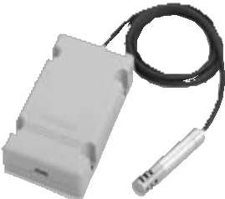HTY7843

**Remote Temperature/Humidity Sensor**

The HTY7843 is a highly precise and reliable sensor that uses a Pt100 platinum RTD (JIS C 1604 Class A) as the temperature sensing element and a polymer capacitive film as the humidity sensing element (the Yamatake-designed FP3TM). This sensor has a wide measuring range and excellent stability. Therefore, it is suitable for measurement of the outside air and for various industrial locations, such as the inside of air- conditioner ducts and chambers.

# Specifications

|  |  |  |  |
| --- | --- | --- | --- |
| **Sensing** | **Temperature** | -20 to +80°C (under limited operating conditions) | |
| **range** | **Humidity** | 0 to 100% RH (no condensation allowed) | |
| **Detection accuracy** | **Temperature** | ±0.3°C (Pt100 output)  ±0.5°C (1-5Vdc output)  ±0.5°C (4-20mAdc output) | |
| **Humidity** | ±3% RH (30 to 70% RH at 25°C)  ±5% RH (20 to 80% RH at 15 to 35°C) | |
| **Output signal** | **Temperature** | JIS Pt100 (3-wire type)  1–5Vdc (Temperature range is specified by model.). Max. input impedance is 50k.  4–20mAdc (2-wire type). Max. load resistance at a power voltage of  24Vdc is 500. | |
| **Humidity** | 1–5Vdc / 0–10Vdc (Linear to 0 to 100% RH). Max. input impedance is 50k.  4–20mAdc (2-wire type). Max. load resistance at a power voltage of  24Vdc is 500. | |
| **Time**  **constant** | **Temperature** | 3min or less | At wind velocity of 2m/s |
| **Humidity** | 30s or less |
| **Power** | | 24Vdc ±10% | |
| **Power consumption** | | 0.2W or less (when voltage output is used for humidity output) | |
| **Dielectric strength** | | Leakage current is 1mA or less when 500Vac is applied for 1 min  (between case and power terminal) | |
| **Insulation resistance** | | 20M or more when measured using 500Vdc megger (between case  and power terminal) | |
| **Protective structure** | | Probe is dustproof and splash-proof (IP54) when filter is attached. | |
| **Accessories** | | Cable tie (1 unit), sponge pad (1 unit) | |
| **Mass** | | Approx. 150g (probe: approx. 60g) | |

I II III IV V Example: **HTY7843D1100**

**Selection Guide**

|  |  |  |  |  |  |
| --- | --- | --- | --- | --- | --- |
| **Segment** | **Model No. selection** | | | | **Description** |
| I | Basic No. | **HTY7843** | ✵ | ✵ | Remote temperature/humidity sensor |
| II | Power | **D** | O | O | 24Vdc |
| III | Humidity output | **1** | O | – | Voltage output, 1–5V / 0–100% RH |
| **4** | – | O | Current output (2-wire type), 4–20mA / 0–100% RH |
| IV | Temperature output | **1** | O | – | Voltage output, 1–5V / 0–50°C |
| **4** | – | O | Current output (2-wire type), 4–20mA / 0–50°C |
| **A** | O | – | Voltage output, 1–5V / 15–35°C |
| **P** | O | O | Resistance output, JIS Pt100 (3-wire type) |
| V | (Fixed) | **00** | O | O | – |

* A circle (o) denotes availability.

# Accessories (sold separately)



**SENSORS**

|  |  |
| --- | --- |
| **Model No.** | **Description** |
| **FL-PA112** | Wall mounting bracket |
| **83104098-003** | Sealed connector without filter |
| **83104098-004** | Sealed connector with filter |
| **83162951-002** | Filter |

(Unit: mm)

**Dimensions**

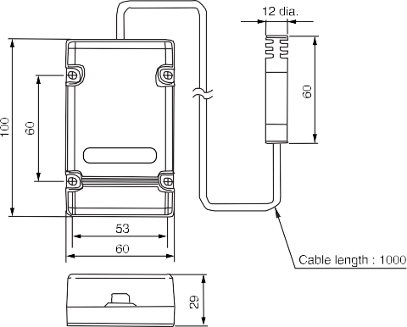

6-14